**REPORT**

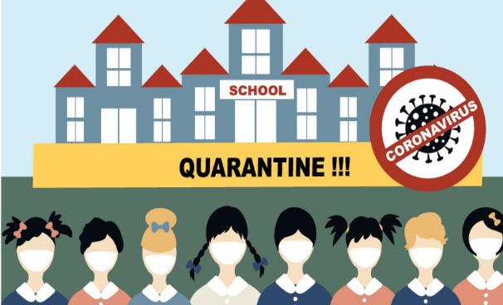We are going through very difficult days. During the quarantine process, many areas, especially education life, were cautious during the quarantine process. Of course, in this process, we can say that home education has started for students. Countries have announced that they are switching to distance education, or even taking a break from education altogether.

According to the statistics of 100 countries, there are more than 860 million students in primary, high school and undergraduate education. In other words, the education life of millions of students was restricted or stayed away during this process. But with the availability of the vaccine, students will be more likely to return to school. In the academic life of 2021-2022, many countries will open their schools. Of course, in this process, although many schools tried to switch to gradual education, they could not succeed.

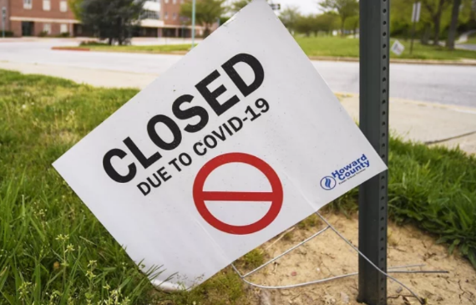 According to UNESCO statistics, schools in Turkey have been closed for more than 41 weeks. Even with the transition to distance education, many students could not continue their education life in a positive sense due to the inadequacy of internet connections and technological impossibilities. Other statistics are 198,613,483 affected learners, 11.3% of total enrolled learners, 21 country-wide closures.

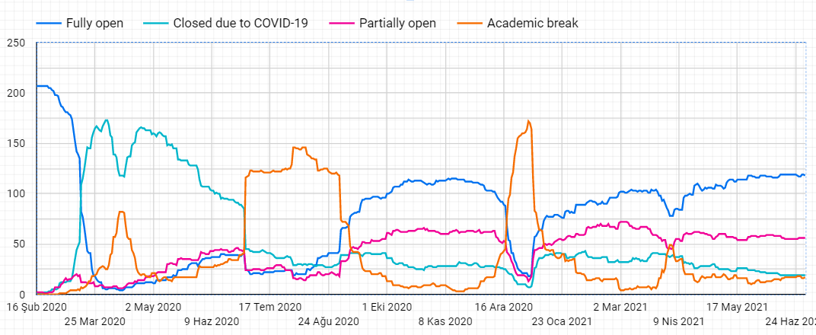Looking at the chart below, we are seeing an almost complete shutdown in the end of Q1 and Q2 of 2020. With this closure that came after the corona virus spread to the world, millions of students were cut off from their education life for a while. However, despite this, it is understood that many countries have decided to return to education in the last quarter of 2020, with the good news and increased measures. Along with the gradual opening measures; return to social life and the process of starting schools were encouraged.

**Despite all these measures, we could not prevent the virus, so the opening of schools decreased in the first quarter of 2021. However, it can be seen that we can start to give signals to return to our old life after the vaccine is presented to the world.**

As the same statistics can be seen here, despite many attempts, we encounter a change of decision in the last quarter of 2020. Due to the events and the inadequacy of the measures taken, many countries still keep their schools closed or continue partially open.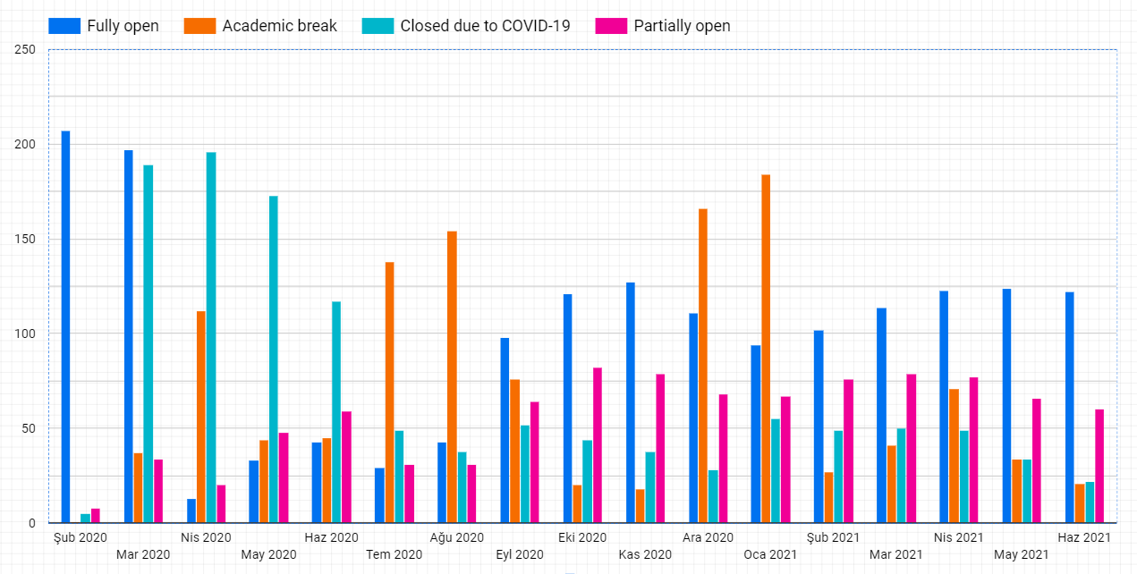

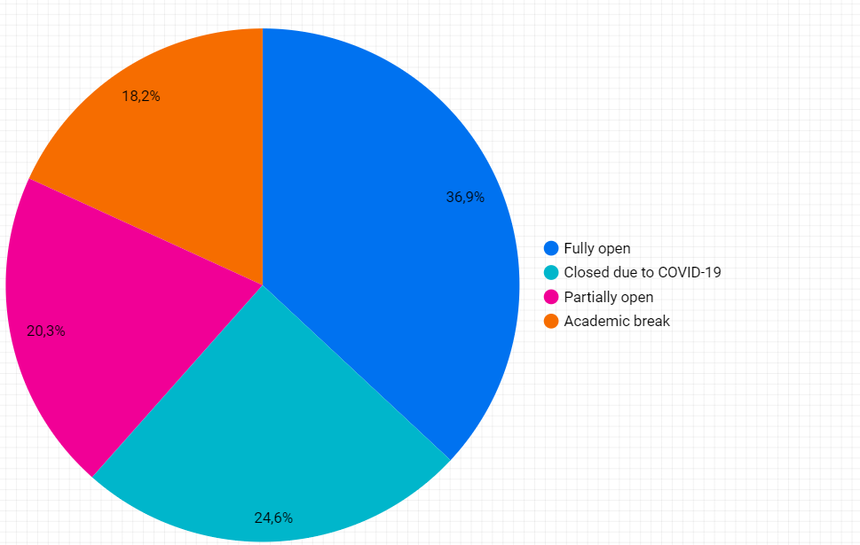In the chart below, we see an average graph of how the school process has continued from the start of the pandemic to this day. When we look at the statistics, as we see in the pink (partially open) and turquoise (closed due to COVID 19) slices after the compulsory academic holidays during the year, a portion of 50 percent shows us the process of education life. This means that people show a huge decline in their educational life during this time.

However, UNESCO offers us quite a lot of content and tables on this subject. By downloading data sets, we can analyze and interpret statistics.

When all these tables are taken into account, there is a huge coronavirus spike around the world. With the new cases that develop in an insignificant way, the possibility of opening schools is decreasing. Countries, especially Italy, face thousands of cases within months.

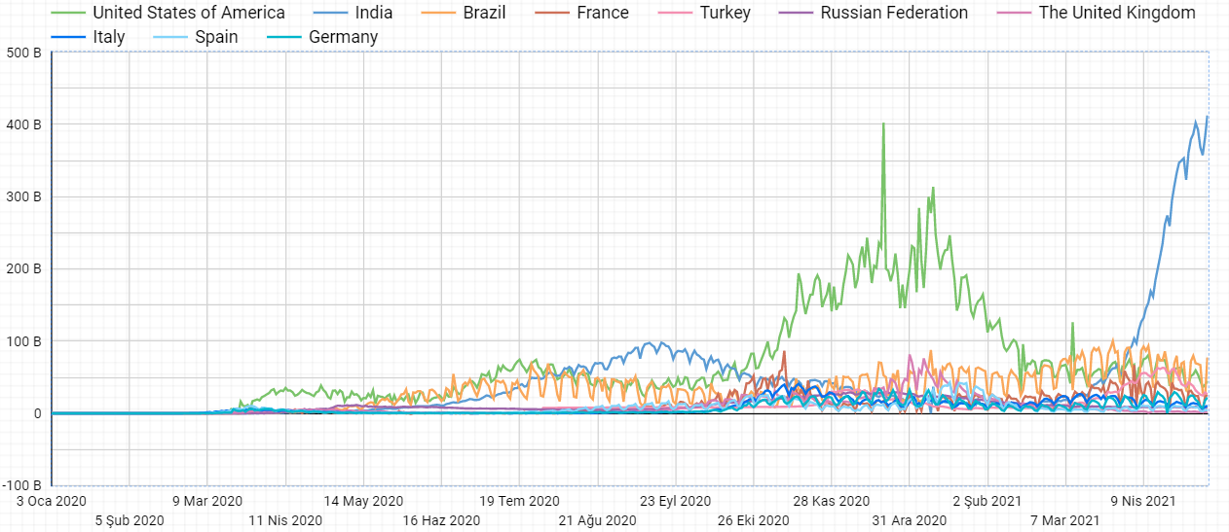Especially in the last quarter of 2020 and the first quarter of 2021, there is a stable number of cases in countries. After America got away from normalization with its leap, Italy followed suit. Education continued in the same way during all these stable cases.

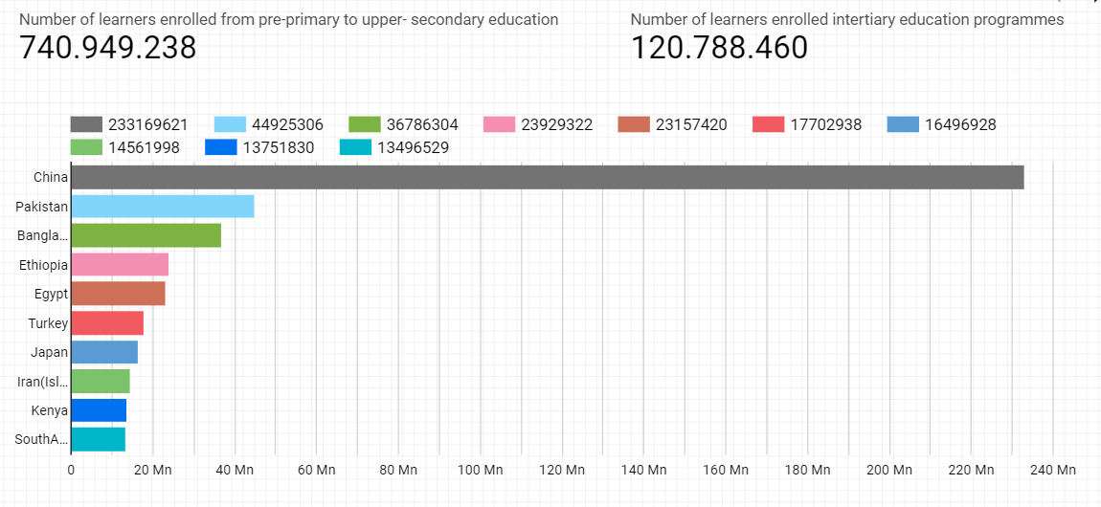Finally, in this ongoing process, students continue their lives partially open or closed. Especially in China, which has an important share in the world population, this process is very difficult for more than 220 million students.

Unicef's statement is as follows:

It is as follows: “Children cannot afford another year of school disruption”.

.